**Part 1: Download the Client Files to Mike’s PC**

**Step 1: Access the FTP server from Mike’s PC.**

a.     Click the **Gotham** **Healthcare Branch**site and then click the PC **Mike**.

b.    Click the **Desktop** tab and then click **Web Browser**.

c.     Enter the URL **http://www.cisco.corp** and click **Go**.

d.    Click the link to download the most current files.

What protocol was used to access this webpage on the backup file server?

HTTP

**Step 2: The file server has been hacked, notify Sally.**

a.     Within the **Gotham** **Healthcare Branch**site, click the PC **Mike**.

b.    Click the **Desktop** tab and then click **Email**.

c.     Create an email and send it to [Sally@cisco.corp](mailto:Sally@cisco.corp) and tell her about the File Server.

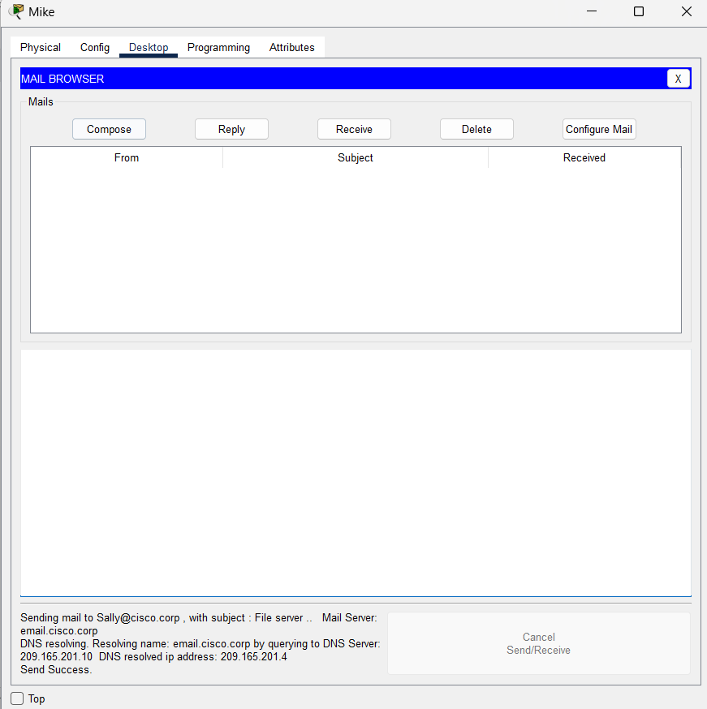

**Part 2: Download the Client Files from the Backup File Server to Mike’s PC**

**Step 1: Access the offsite FTP server from Mike’s PC.**

a.     Within the **Gotham** **Healthcare Branch**site, click the PC **Mike**.

b.    Click the **Desktop** tab and then click **Web Browser**.

c.     Enter the URL **https://www.cisco2.corp** and click **Go**.

d.    Click the link to view the most recent files and their hashes.

What protocol was used to access this webpage on the backup file server?

HTTPS

What are the file names and hashes of the client files on the backup server? (copy and paste them below)

FileName | NWclients.txt | Hash| dd88482282785192d4a4ad4f8e32b3b6  
FileName | SWclients.txt | Hash| c202036c9210959e7b587b08f080c378  
FileName | NEclients.txt | Hash| 6c8fb699ac2ced0b5c9ea40aab9f8caf  
FileName | SEclients.txt | Hash| 48d7eceee217e83cd685b537a3066b2f  
FileName | Sclients.txt | Hash| abad7f7606e324f252bfebd6c09810e2  
FileName | Nclients.txt | Hash| 65f586602d9476b7b561b5d98b2ea23b

**Step 2: Download the client files to Mike’s PC.**

a.     Within the **Gotham** **Healthcare Branch**site, click the PC **Mike**.

b.    Click the **Desktop** tab and then click **Command Prompt**.

c.     Connect to the **Backup File**server by entering **ftp www.cisco2.corp**in the command prompt.

d.    Enter the username of **mike** and a password of **cisco123**.

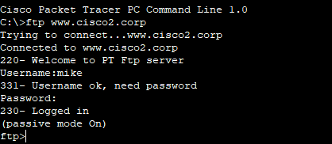

e.     At the **ftp>** prompt, enter the command **dir** to view the current files stored on the remote FTP server.

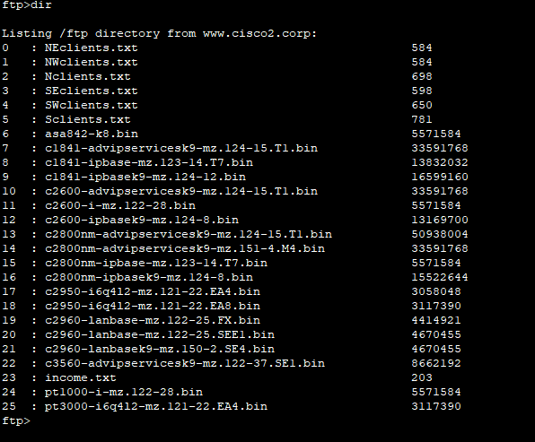

f.     Download the six client files (NEclients.txt, NWclients.txt, Nclients.txt, SEclients.txt, SWclients.txt, and Sclients.txt) to Mike’s PC by entering the command **get FILENAME.txt**, replace FILENAME with one of the six client filenames.

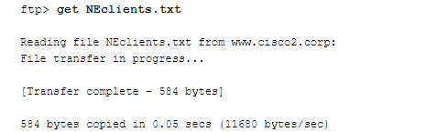

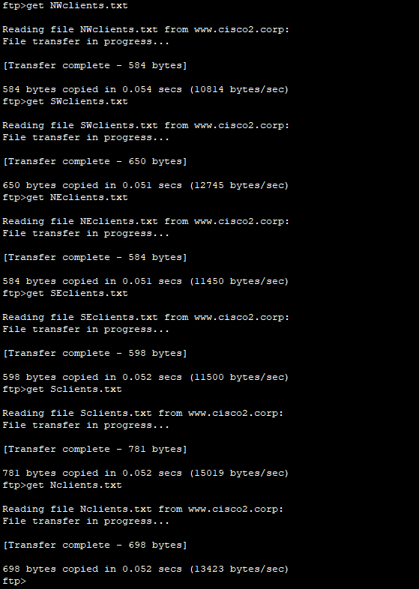

g.    After downloading all the files, enter the command **quit** at the **ftp>**prompt.

h.     At the **PC>** prompt, enter the command **dir** and verify the client files are now on Mike’s PC.

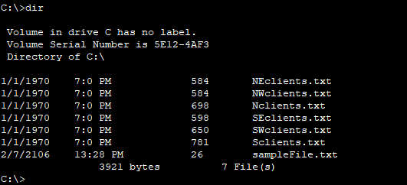

**Part 3: Verify the Integrity of the Client Files using Hashing**

**Step 1: Check the hashes on the client files on Mike’s PC.**

a.     Within the **Gotham** **Healthcare Branch**site, click the PC **Mike**.

b.    Click the **Desktop** tab and then click **Text Editor**.

c.     In the Text Editor window, click **File** > **Open**.

d.    Click on the first document **NEclients.txt** and click **OK**.

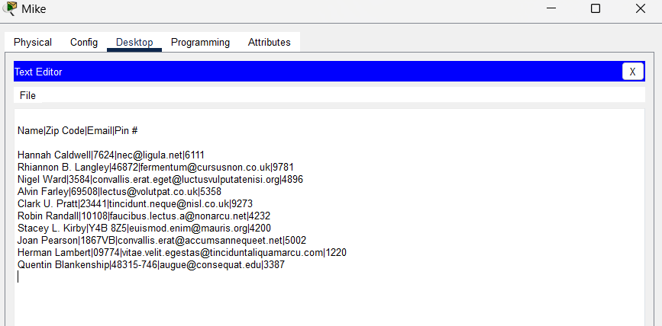

e.     Copy the entire text document contents.

f.     Open a web browser on your personal computer and browse to the website <https://www.tools4noobs.com/online_tools/hash/>

g.    Click the whitespace and paste in the text document contents. Make sure the algorithm is set to md2. Click **Hash this!**.

h.     To make sure a file has not been tampered with, you will compare the resulting hash with the filename/hash information you found in Part 2 Step 1.

i.      Repeat Steps d through h for each client file and compare the generated hash with the original hash shown in Part 2 Step 1.

Which file has been tampered with and has an incorrect hash? SEclients.txt

**Step 2: Download the suspected file to Sally’s PC.**

a.     Click the **Metropolis Bank HQ**site, and then click the PC **Sally**.

b.    Click the **Desktop** tab and then click **Command Prompt**.

c.     Connect to the **Backup File**server by entering **ftp www.cisco2.corp**in the command prompt.

d.    Enter the username of **sally** and a password of **cisco123**.

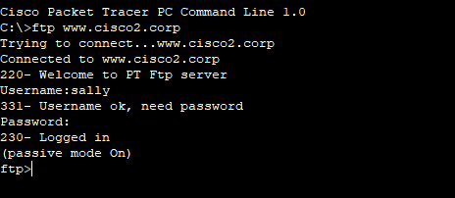

e.     At the **ftp>** prompt, enter the command **dir** to view the current files stored on the remote FTP server.

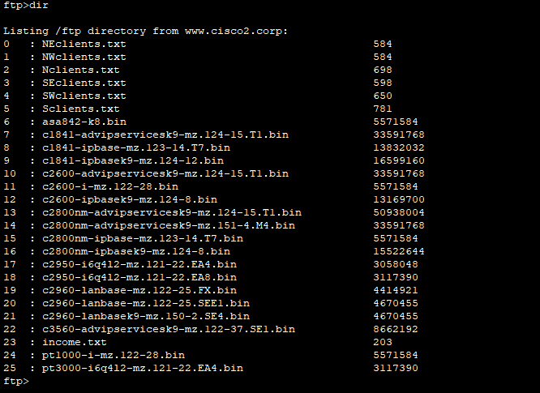

f.     Download the file that was found to have been tampered with in Part 3 Step 1.

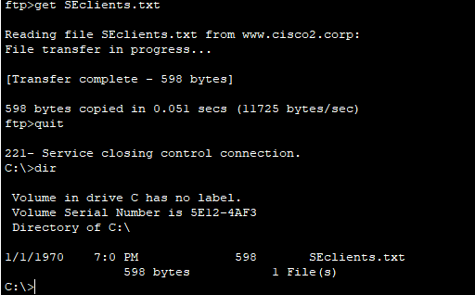

g.    At the **ftp>** prompt, enter the command **quit**.

h.     At the **PC>** prompt, enter the command **dir** and verify the tampered client file is now on Sally’s PC for analysis at a later time.

**Part 4: Verify the Integrity of Critical Files using HMAC**

**Step 1: Compute the HMAC of a critical file.**

a.     Within the **Metropolis Bank HQ**site, click the PC **Bob**.

b.    Click the **Desktop** tab and then click **Command Prompt**.

c.     At the **PC>** prompt, enter the command **dir** and verify the critical file named **income.txt** is on Bob’s PC.

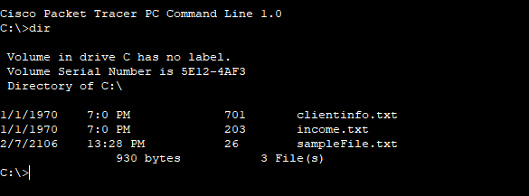

d.    Within the **Desktop** tab, click **Text Editor**.

e.     In the Text Editor window, click **File** > **Open**.

f.     Click the document **income.txt** and click **OK**.

g.    Copy the entire text document contents.

h.     Open a web browser on your personal computer and browse to the website <http://www.freeformatter.com/hmac-generator.html>

i.      Click the whitespace and paste in the text document contents. Enter the secret key of **cisco123**. Make sure the algorithm is set to **SHA1**. Click **Compute HMAC**.

What is the computed HMAC for the contents of the file?

96a6e980220c282a1aebbdafccd629a1b9ad397dac875c9cbd66bd3175e73991

How is using HMAC more secure than general hashing?

To produce a specific hash you need both the original message and a secret key.

**Step 2: Verify the computed HMAC.**

a.     Within the **Metropolis Bank HQ**site, click the PC **Bob**.

b.    Click the **Desktop** tab and then click **Web Browser**.

c.     Enter the URL **https://www.cisco2.corp** and click **Go**.

d.    Click on the link to view the most recent files and their hashes.

Does the HMAC hash for the income.txt file match?

Yes

